# CREATE A DATABASE IN CLOUDANT DB

|  |  |
| --- | --- |
| Date | 10 November 2022 |
| Team ID | PNT2022TMID18986 |
| Project Name | Gas leakage monitoring and alerting system for  industries |

**Create A Database In Cloudant DB.**

**Aim:** To create a database in Cloudant DB to store location data. Steps followed:

* Logged in to IBM Cloud account.

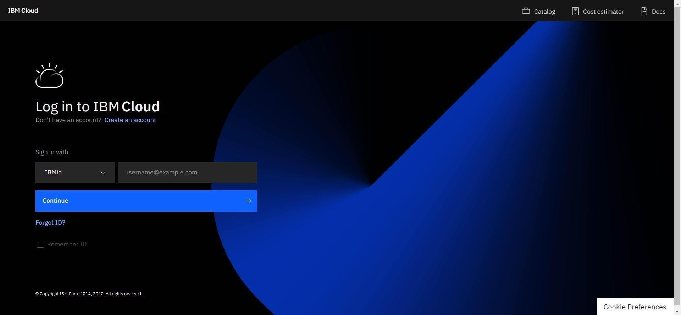

* Clicked on the “Create Resource +” button.

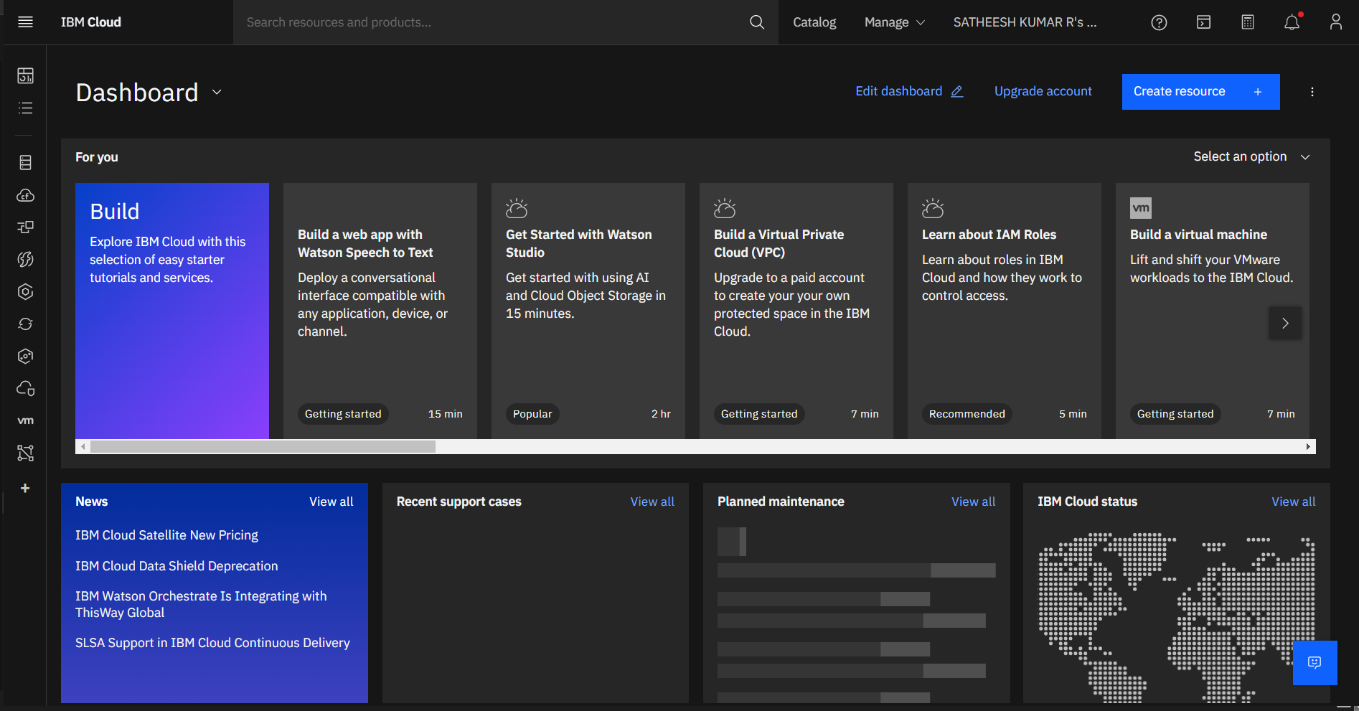

* Searched for “Cloudant”.

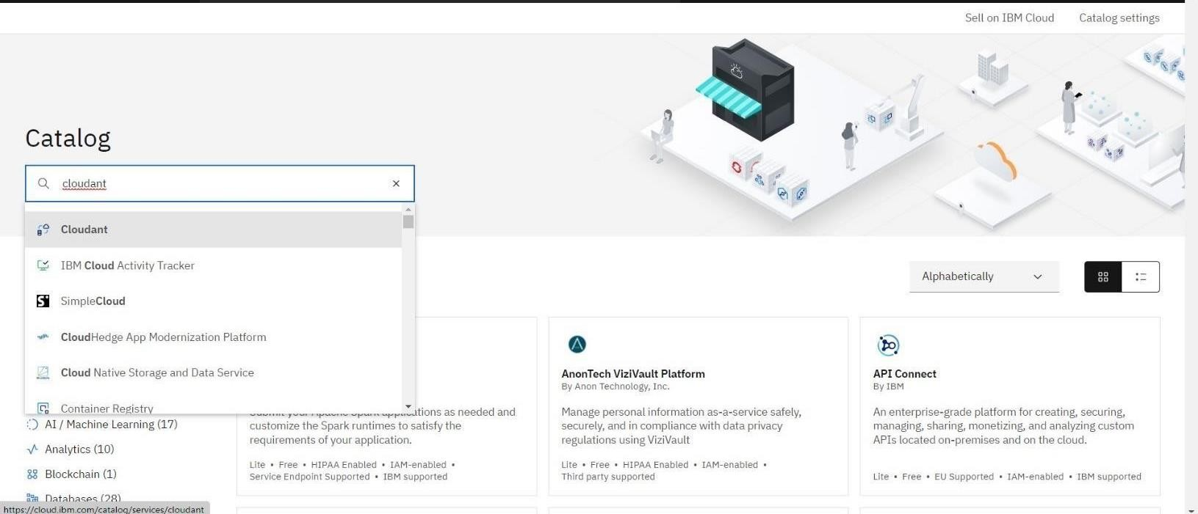

* + Chose the “Lite Version” and clicked on “Create”.

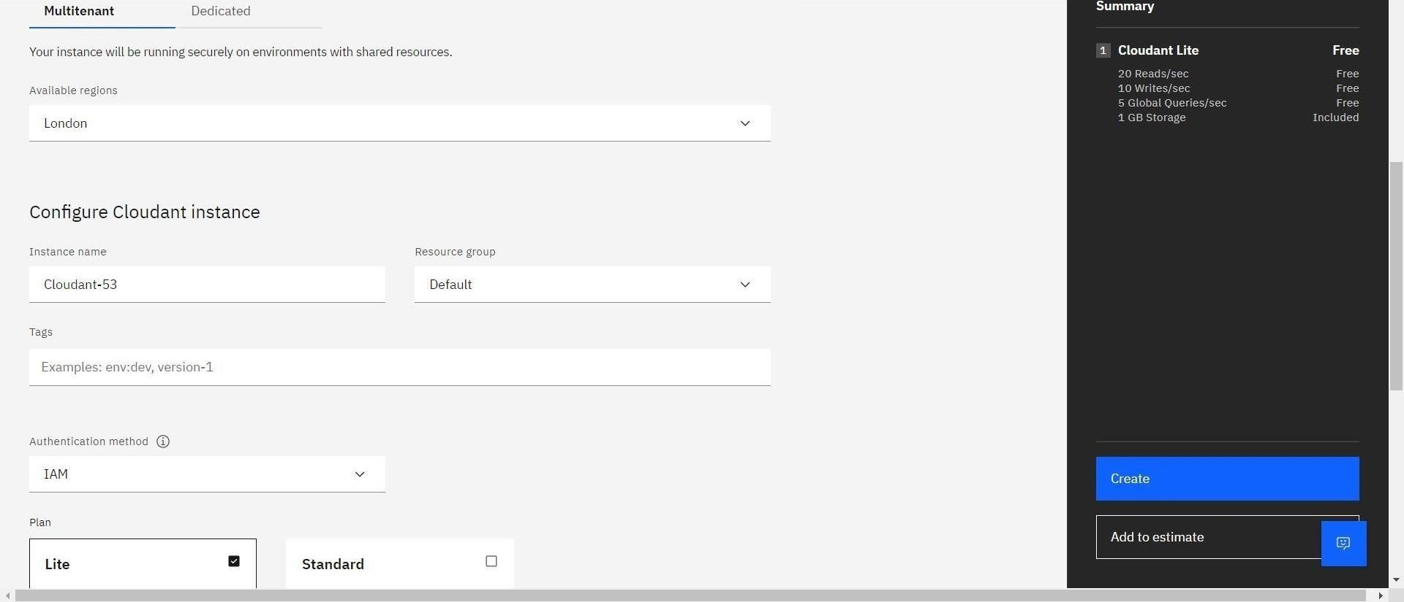

* The Cloudant database resource was created successfully

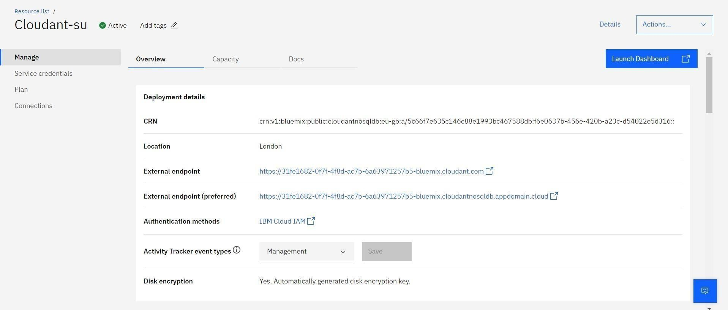

* Clicked on Launch Dashboard

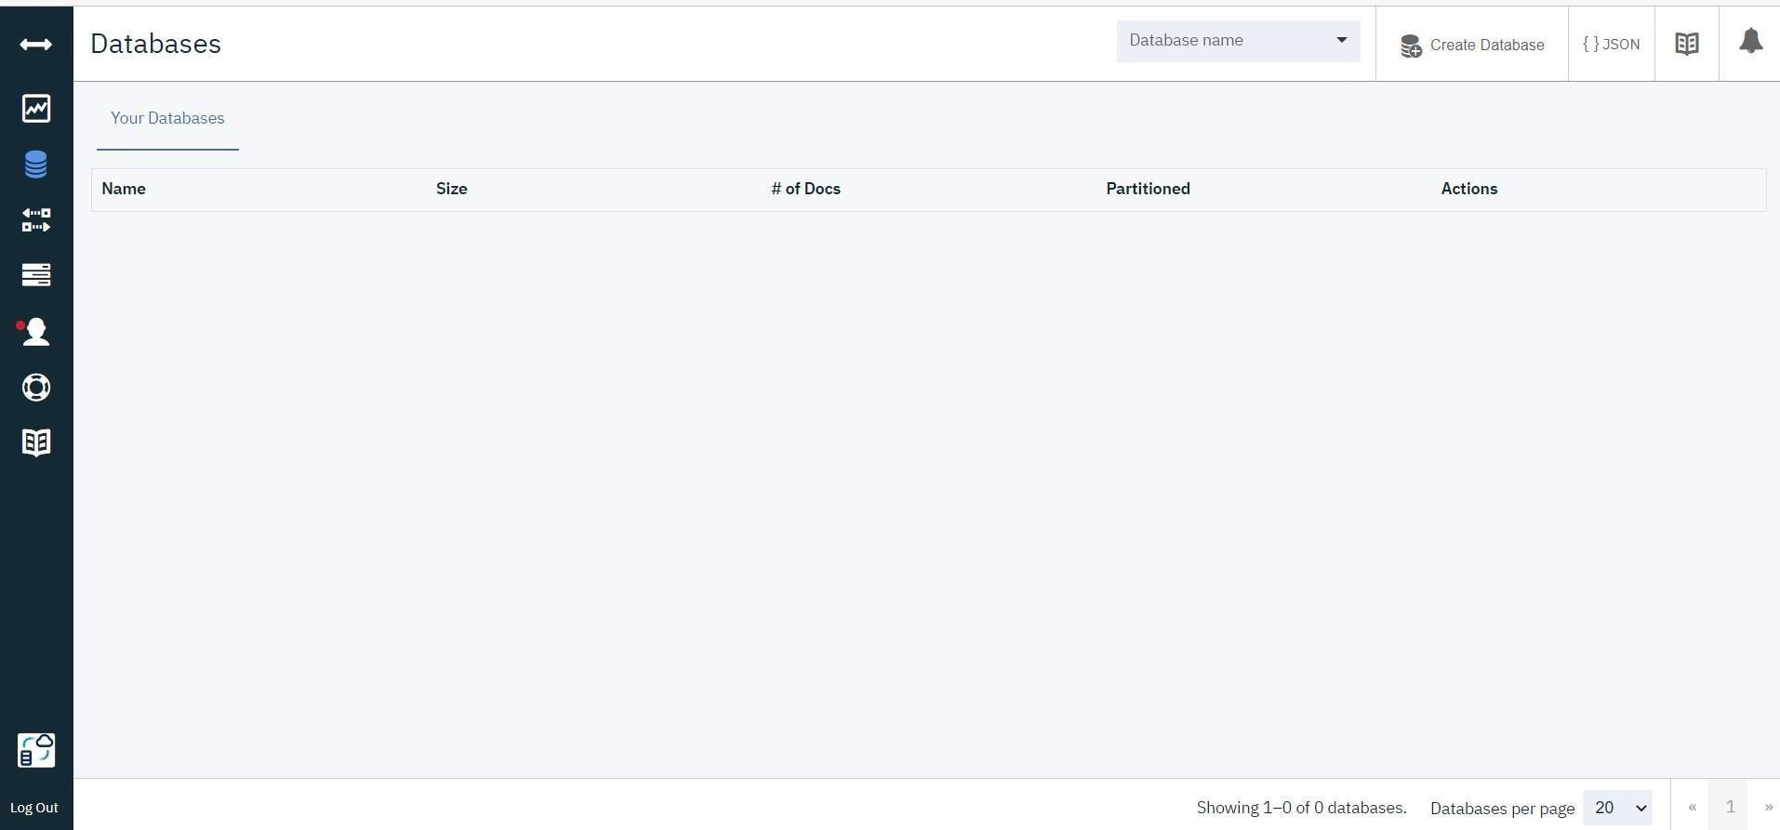

* Clicked on “Create Database”. Entered “success” as the database name and the “Non-partitioned” option.
* Database is created successfully.

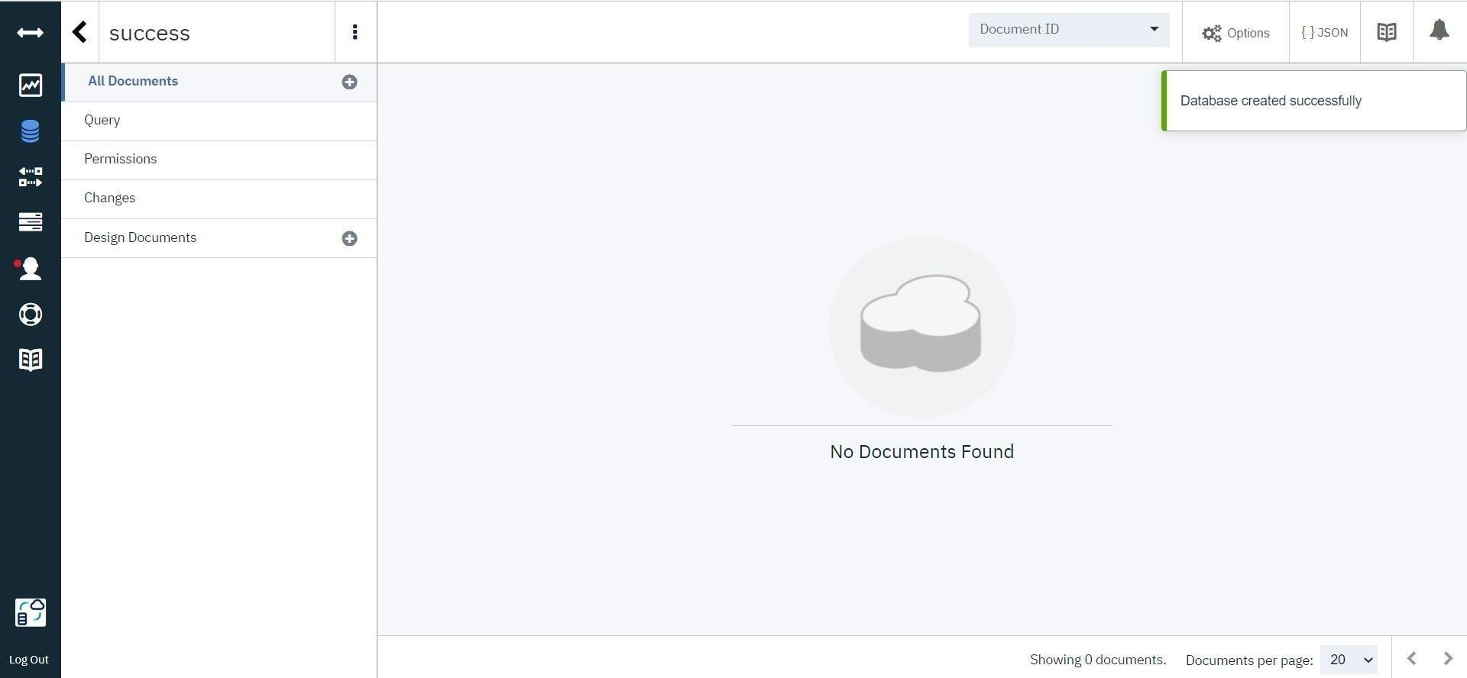

# Result:

A database to store the location data was created successfully on Cloudant DB.